EX NO:05
DATE:
EDUREKA INTERACTIVE DASHBOARD

AIM: To create an interactive dashboard in Tableau using the Edureka dataset to identify and analyze the most popular courses through various visualizations and dashboard objects, enabling users to explore course popularity and compare course performance effectively.
- Create an Interactive dashboard for Edureka’s most popular courses available in the dataset, by adding various forms of objects to it. (Data set: Edureka)
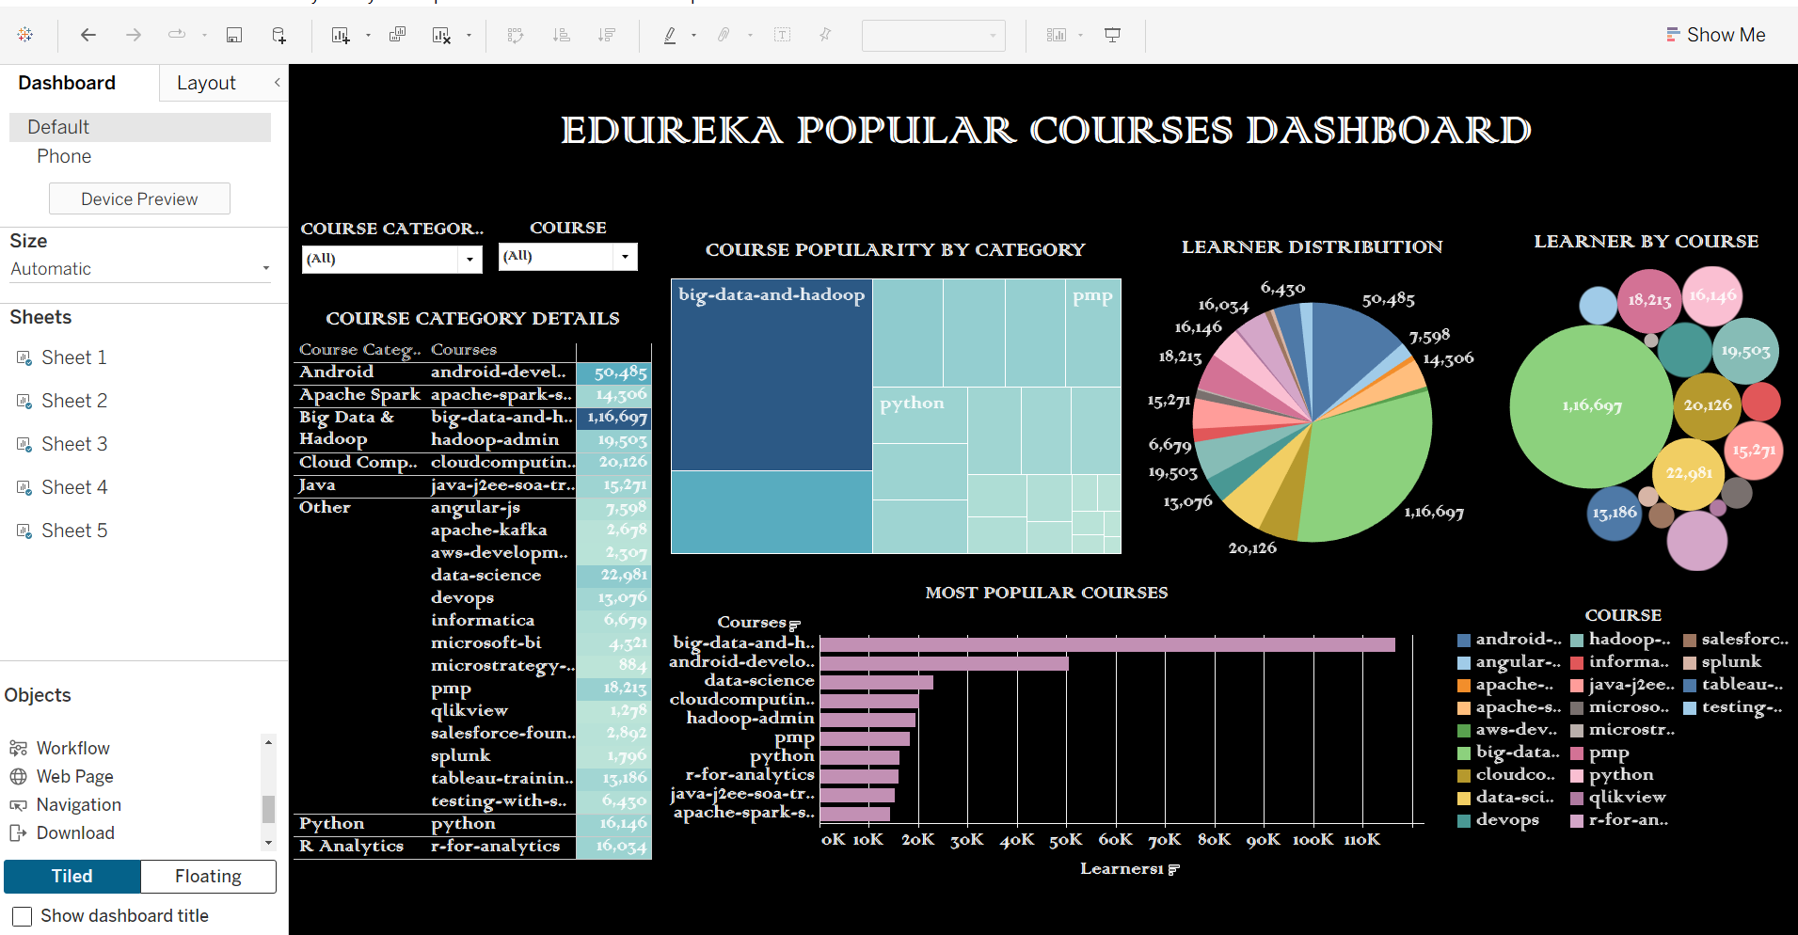

INTERPRETATION:
The interactive dashboard provides an overview of Edureka’s most popular courses using different visualizations and dashboard objects. It helps users compare course popularity, identify courses that attract greater interest, and understand differences in course performance. The interactive features allow users to explore the available data and focus on specific courses or categories. Overall, the dashboard helps Edureka understand course preferences, identify popular learning areas, and make informed decisions regarding course development, promotion, and marketing strategies.

THESE ARE THE CHARTS USED IN THE DASHBOARD.

